TailorMade  
MODELLING, MATCHING, MAKING

Blibli ***FUTURE*** Program Batch 4.0

Fase 3 – Medan Kota



Oleh:

Syntia

REQUIREMENT DOCUMENT

# Introduction

## Software Motivation and Scope

Clothes is one of the primary needs that can’t be separated from daily needs. In some events, such as wedding or school farewell party, people tend to need clothes which can be customized as they wish. Hence, people have to find shop, tailor or convection business who are able to make the clothes, according to the design quality and price. This creates a problem, where not all parties who can make the desired clothes are in an accessible location. Other than that, sometimes customer and tailor think that another variable such as cloth quality and offered price isn’t match.

From tailor’s perspective, it’s difficult to produce clothes customer wants because of his/her high expectations for the clothes. The tailors themselves have variety of skills so they cannot make the clothes that customers want to the fullest.

TailorMade would be the solution of the problems. TailorMade is an e-commerce that connects tailors and customers. It introduces technology and e-commerce for customers and tailors as a place to make online transactions. This makes it easier for customers to find a tailor and make transactions without the need to meet the tailor first. Customers can also find the right tailor to create the desired clothes design, because there are examples of designs that have been made by the tailor. In addition, the process of customization and negotiation is also facilitated by online communication, allowing tailors to better understand what customers want.

## Definition

Frequently used words defined in the table below.

|  |  |
| --- | --- |
| ****Cart**** | Saves user order list. |
| ****Categories**** | Categories; group a product by type. |
| ****Chat**** | Talk in a friendly and informal way from the system. |
| ****Data**** | Information based on facts; description of an event. |
| ****Database**** | A set of data saved in a system. |
| ****ERD**** | *Entity Relationship Diagram*; Diagram that shows two or more data tables and the relationship between them. |
| ****Home**** | System’s landing page. |
| ****Log in**** | Get access to the system with user account identity and log in as the user. |
| ****Log out**** | Log out of an active account. |
| ****Profile**** | Contains user information. |
| ****Order**** | Request product to be made, supplied, or served. |
| ****Search**** | Try to find something by using keywords. |
| ****SRS**** | *Software Requirement Specification*; A detailed description of a software system to be developed with its functional and non-functional requirements. |
| ****User**** | A person who uses or operates application as a customer. |
| ****Tailor**** | A person whose occupation is making fitted clothes such as suits, pants, and jackets to fit individual customers; uses or operates application as a tailor. |

## References

The references that used in helping the process of making this SRS document:

* [*http://cheesterzone.blogspot.com/2011/04/dokumen-srs-sistem-informasi.html*](http://cheesterzone.blogspot.com/2011/04/dokumen-srs-sistem-informasi.html)
* [*https://hasrulbakri.wordpress.com/2011/05/23/contoh-dokumen-srs-software-requirement-spesification/*](https://hasrulbakri.wordpress.com/2011/05/23/contoh-dokumen-srs-software-requirement-spesification/)
* http://www.cse.msu.edu/~chengb/RE-491/Papers/SRSExample-webapp.doc

## Systematics

The SRS document is divided into four main parts:

**Introduction**, contains an explanation of the purpose of making and the scope of problems that is affected by the application being developed, definitions, references and systematics.

**General Description**, contains a general explanation about the application being developed, include the perspective general description of the system, user characteristics, limitations and assumptions of use.

**Requirement Specifications**, contains a description of the application requirements in more detail.

**User Story**, contains user stories for every role.

# General Description

## Perspective

Application is made for user (customer and tailor) who interests to clothes and fashion design. Both user and tailor have access rights to use the application, while anonymous user must register first.

When a new user register to the application, user data will be saved to the database and user may have a workspace. After that, user may log in to or log out from the application everytime.

From user perspective as a customer, users are expected to be able to get the clothes they want faster. They may use the application with 3 steps:

* **modelling (by searching for a design or using his/her own design),**
* **matching (make some negotiation or fitting with the tailor in chat), and**
* **making (order the clothes).**

Users are also expected to be able to swap their face with design’s face to match their face with the clothes, or just for having fun with the application.

Meanwhile, from user point of view as a tailor, tailors are expected to be able to create, read, update, and delete their product design. Tailors may edit their information to be shown to customers. Other than that, tailors also are expected to accept or reject incoming order from customers and show recent orders.

## Usability

Product enables User and Tailor to be connected and make some online cloth-making transactions.

Functions of the product are

|  |  |
| --- | --- |
| User | Tailor |
| Login  Sign Up  Tailor  Search  Product (Design)  Swap Face  Chat  Cart  Order History  Profile | Login  Sign Up  Product(Design)  Search  Chat  Order (Incoming & Recent)  Profile |

## User Characteristics

These are two roles of user with their characteristics.

|  |  |
| --- | --- |
| **User** | **Characteristics** |
| User | User (customer) be able to show and search tailors and their products design, swap face with the face in a design, chat with the tailors, and order a design online. |
| Tailor | Tailor may create, show, update and delete the products design, chat with the users, and accept/reject an order from user. |

## Limitations

Limitations in using the application are

1. System can only run in an Android device with Operating System minimal Lollipop OS (5.0),
2. Users who have access rights to all provided features are they who have registered in the system,
3. Registered tailor can only sell design making services like a store.

## Assumptions and Dependences

Assumptions and dependences in using this application are

1. Users have understood how to use e-commerce services, and
2. All payment will be success automatically.

# Requirement Specifications

## Functional Requirements

The following shows each role Use Case Diagram.

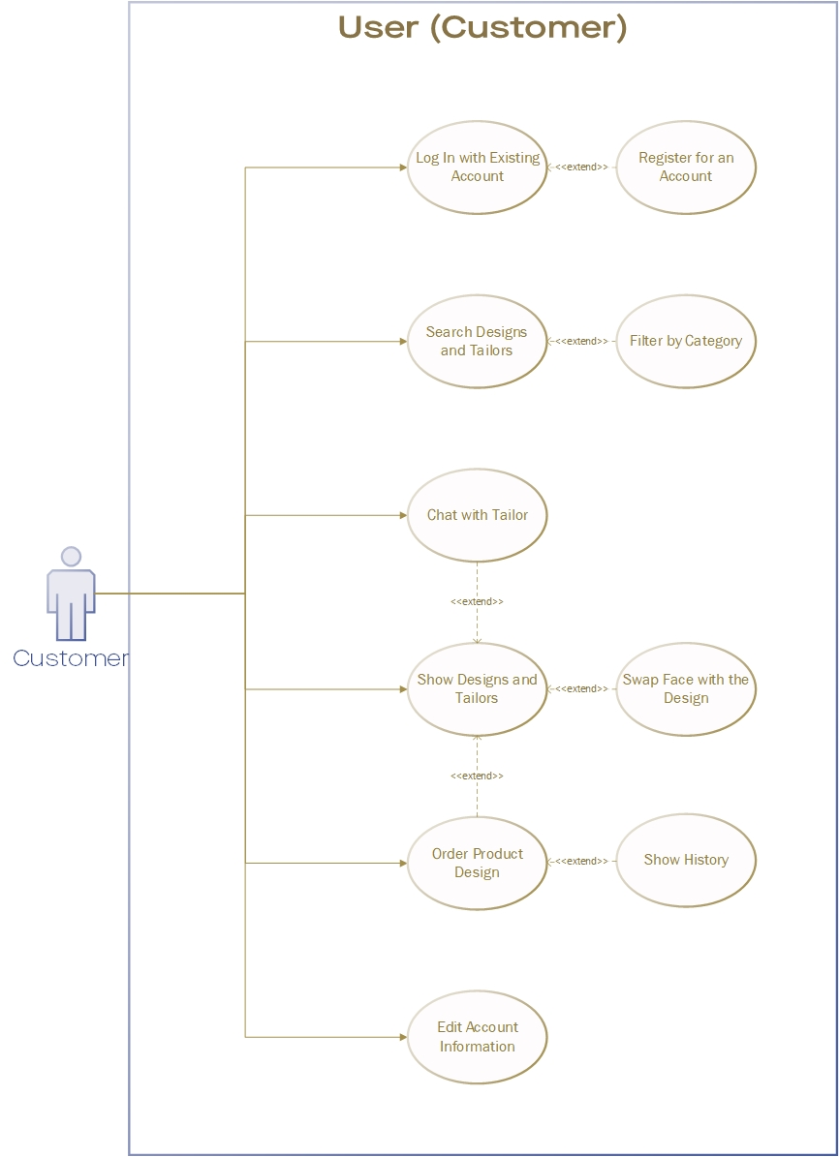

Figure 1 Use Case Diagram for User (Customer) Role

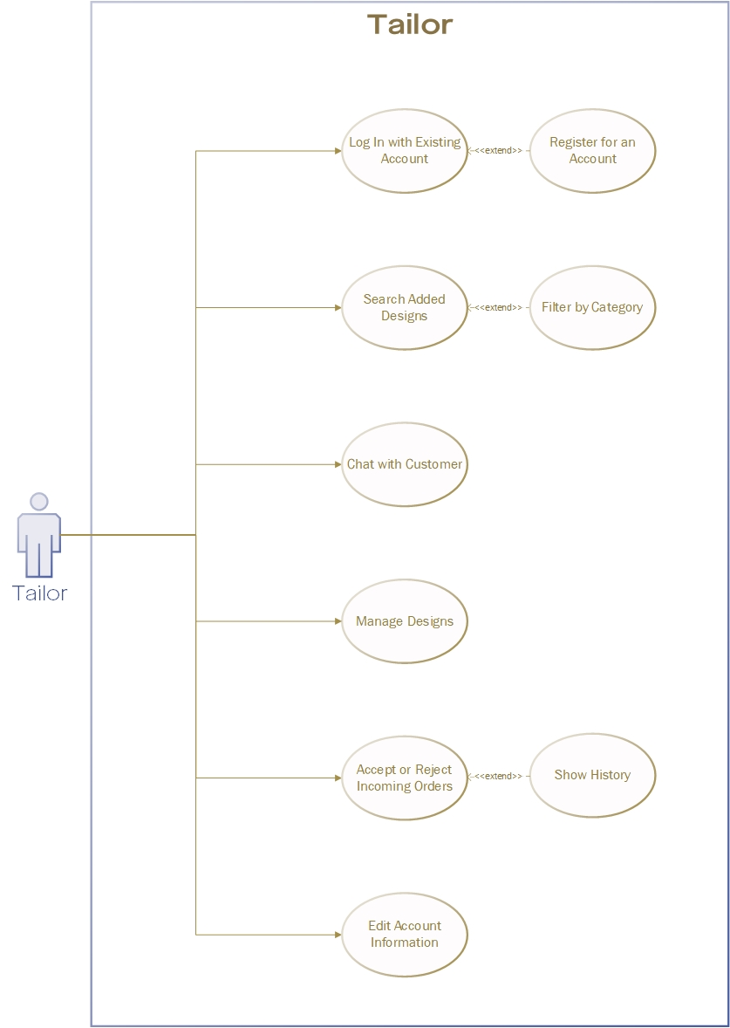

Figure 2 Use Case Diagram for Tailor Role

And the following is the Use Case Scenario from the diagram.

### Log in

|  |  |  |
| --- | --- | --- |
| Use Case Name | Log in | |
| Scenario | Login an account to use the web | |
| Triggering Event | Clicking some features that only available to verified account.  Clicking Log in / Register menu. | |
| Brief Description | User must log in to use all of the provided features and have an account.  Tailor and Admin must log in before using the web and have an account. | |
| Actors | User, Tailor, Admin | |
| Pre-conditions | User, Tailor, Admin hasn’t logged in | |
| Post-conditions | User, Tailor, Admin has logged in | |
| Flow of Activities | **Actor** | **System** |
| 1. User, Tailor, Admin click Log in / Register menu | * 1. System loads the UI for login |
| 1. User, Tailor, Admin type the username and password |  |
| 1. User, Tailor, Admin click on login button | * 1. System validates the username and password   2. System informs the user of successful login by show the home UI for each role.   3. System loads the home UI. |
| Exceptions Conditions | * 1. User, Tailor, Admin failed to Log in due to unstable Internet connection.   2. User, Tailor, Admin failed to Log in caused by wrong username / password.   3. User, Tailor failed to Log in because the account is blocked from the system. | |

### Register as User / Tailor

|  |  |  |
| --- | --- | --- |
| Use Case Name | Register as User / Tailor | |
| Scenario | Register as an User / a Tailor | |
| Triggering Event | Clicking Log in / Register menu.  Clicking Register menu. | |
| Brief Description | User / Tailor input all the required field such as username, email, password. | |
| Actors | User, Tailor | |
| Pre-conditions | User, Tailor hasn’t have an account | |
| Post-conditions | User, Tailor has an account and has logged in. | |
| Flow of Activities | **Actor** | **System** |
| 1. User / Tailor click Log in / Register menu | * 1. System loads the UI for login |
| 1. User / Tailor type all the required information, such as username and password. |  |
| 1. User / Tailor click on Sign up button | * 1. System validates all the field in form   2. System successfully registered an account in database   3. System automatically logged in the User / Tailor by show the home UI for each role. |
| Exceptions Conditions | 3.2. User / Tailor failed to register due to an error in some field, such as username already exists. | |

### Edit Profile

|  |  |  |
| --- | --- | --- |
| Use Case Name | Edit Profile User | |
| Scenario | View or Edit Profile of an User account | |
| Triggering Event | Clicking Profile menu.from Hamburger icon.  Clicking Profile photo on Review button in Product page (if user has reviewed on a product) | |
| Brief Description | User fill/edit their personal information such as Address, Phone Number, etc. | |
| Actors | User | |
| Pre-conditions | User hasn’t complete / change their personal information | |
| Post-conditions | User has completed / changed their personal information | |
| Flow of Activities | **Actor** | **System** |
| 1. User click Profile menu | * 1. System loads the UI for edit profile |
| 1. User fill / change some or all the required information, such as Address, Phone Number. |  |
| 1. User click on checklist (Done) button. | * 1. System successfully filled / changed the information in database   2. System redirects to Home UI |
| Exceptions Conditions | 3.1. User failed to change / fill the information due to unstable Internet connection. | |

### Edit Storefront Page

|  |  |  |
| --- | --- | --- |
| Use Case Name | Edit Storefront Page | |
| Scenario | View or Edit Storefront Page of a Tailor account | |
| Triggering Event | Clicking Edit button on Storefront Page.  Clicking Profile photo on Product page (if Tailor has added a product or more). | |
| Brief Description | Tailor fill/edit their storefront information such as Store Name, Phone Number, etc. | |
| Actors | Tailor | |
| Pre-conditions | Tailor hasn’t complete / change their storefront information | |
| Post-conditions | Tailor has completed / changed their storefront information | |
| Flow of Activities | **Actor** | **System** |
| 1. Tailor click the Edit button on Storefront Page. | * 1. System loads the UI for edit Storefront information. |
| 1. Tailor fill / change some or all the required information, such as Address, Phone Number. |  |
| 1. Tailor click on checklist (Done) button. | * 1. System successfully filled / changed the information in database   2. System redirects to Storefront UI. |
| Exceptions Conditions | * 1. Tailor failed to change / fill the information due to unstable Internet connection. | |

### View / Remove from Wishlist

|  |  |  |
| --- | --- | --- |
| Use Case Name | View / Remove from Wishlist | |
| Scenario | View or Remove favorite product from their Wishlist. | |
| Triggering Event | Clicking Wishlist menu on Hamburger menu. | |
| Brief Description | User be able to view, or remove their favorite product from their Wishlist. | |
| Actors | User | |
| Pre-conditions | User hasn’t remove their favorite product from their Wishlist. | |
| Post-conditions | User has removed their favorite product from their Wishlist. | |
| Flow of Activities | **Actor** | **System** |
| 1. User click the Wishlist menu from Hamburger menu | * 1. System loads the UI for view, edit, or remove from Wishlist. |
| 1. User click Remove button on a wishlist | * 1. System removed the product from User’s Wishlist and from the database. |
| Exceptions Conditions | * 1. User failed to remove the product due to unstable Internet connection. | |

### Add to Wishlist

|  |  |  |
| --- | --- | --- |
| Use Case Name | Add to Wishlist | |
| Scenario | Add favorite product to their Wishlist. | |
| Triggering Event | Clicking “Add to Wishlist” button at Product Page. | |
| Brief Description | User be able to add their favorite product to their Wishlist from Product Page. | |
| Actors | User | |
| Pre-conditions | User hasn’t add their favorite product to their Wishlist. | |
| Post-conditions | User has added their favorite product to their Wishlist. | |
| Flow of Activities | **Actor** | **System** |
|  | 1. User click the “Add to Wishlist” button at Product Page. | * 1. System adds the product to User’s wishlist and to the database   2. System displays pop-up message indicates system successfully added the product to their wishlist. |
| Exceptions Conditions | * 1. User failed to add the product due to unstable Internet connection. | |

### View / Remove from Cart

|  |  |  |
| --- | --- | --- |
| Use Case Name | View / Remove from Cart | |
| Scenario | View or Remove the products from User’s Cart. | |
| Triggering Event | Clicking Cart icon at Navigation Pane. | |
| Brief Description | User be able to view, or remove product from their Cart. | |
| Actors | User | |
| Pre-conditions | User hasn’t remove the products from their Cart. | |
| Post-conditions | User has removed the products from their Cart. | |
| Flow of Activities | **Actor** | **System** |
| 1. User click the Cart icon at Navigation Pane. | * 1. System loads the UI for view, or remove from Cart. |
| 1. User click Remove button on a Cart. | * 1. System removed the product from User’s Cart and from the database. |
| Exceptions Conditions | * 1. User failed to remove the product due to unstable Internet connection. | |

### Add to Cart

|  |  |  |
| --- | --- | --- |
| Use Case Name | Add to Cart | |
| Scenario | Add the product to User’s Cart. | |
| Triggering Event | Clicking “Add to Cart” button at Product Page. | |
| Brief Description | User be able to add their favorite product to the Cart from Product Page. | |
| Actors | User | |
| Pre-conditions | User hasn’t add their favorite product to the Cart. | |
| Post-conditions | User has added their favorite product to the Cart. | |
| Flow of Activities | **Actor** | **System** |
| 1. User click the “Add to Cart” button at Product Page. | * 1. System adds the product to User’s cart and to the database.   2. System displays pop-up message indicates system successfully added the product to the cart. |
| Exceptions Conditions | * 1. User failed to add the product due to unstable Internet connection. | |

### View / Edit Book Library

|  |  |  |
| --- | --- | --- |
| Use Case Name | View / Edit Book Library | |
| Scenario | View or Edit User’s Book Library, to see purchased products. | |
| Triggering Event | Clicking “My Book Library” or “View more” at User’s Home page. | |
| Brief Description | User be able to see their Book Library and read the books from the Book Library. | |
| Actors | User | |
| Pre-conditions | User hasn’t see their Book Library, or hasn’t read the purchased books. | |
| Post-conditions | User has seen their Book Library, or has read the purchased books. | |
| Flow of Activities | **Actor** | **System** |
| 1. User click “My Book Library” or “View more” at User’s Home page. | * 1. System loads the UI for User’s Book Library. |
| 1. User click “Read Now” button at a product. | * 1. System re-direct to pdf opener, then the pdf opener opens the file. |
| Exceptions Conditions | 2.1. User can’t open the book due to unstable Internet connection.  2.1. User can’t open the book because the book is blocked / not available. | |

### Purchase Product

|  |  |  |
| --- | --- | --- |
| Use Case Name | Purchase Product | |
| Scenario | Purchase the Product from User’s Cart, or from the Product Page. | |
| Triggering Event | Clicking “Purchase Now” button at Product Page.  Clicking “Purchase Now” button at User’s Cart. | |
| Brief Description | User be able to purchase the product from User’s Cart. | |
| Actors | User | |
| Pre-conditions | User hasn’t purchase the selected products from User’s Cart. | |
| Post-conditions | User has purchased the selected products from User’s Cart. | |
| Flow of Activities | **Actor** | **System** |
| 1. User click the “Purchase Now” button at Product Page, or at User’s Cart | * 1. System loads the UI for Purchase page. |
| 1. User chooses a payment method. |  |
| 1. User clicks the “Make Payment” button to order the product(s). | * 1. System added User’s order to the Order List and to the database.   2. System gives the product access rights to the user. |
| Exceptions Conditions | 3.1. User failed to purchase the product due to unstable Internet connection. | |

### Search Product

|  |  |  |
| --- | --- | --- |
| Use Case Name | Search Product | |
| Scenario | Search the available Product by title, or keyword. | |
| Triggering Event | Clicking Search button on navigation pane. | |
| Brief Description | User and Tailor be able to find the available Product by title, or by keyword. | |
| Actors | User, Tailor | |
| Pre-conditions | User and Tailor hasn’t find a specific product. | |
| Post-conditions | User and Tailor has found a specific product. | |
| Flow of Activities | **Actor** | **System** |
| 1. User click the Search icon on the navigation panel. | * 1. System loads the UI for Search Product. |
| 1. User type the keyword or title of the product. |  |
| 1. User click the Search icon. | 3.1. System shows all products related to the search keyword. |
| Exceptions Conditions | * 1. User failed to search the product due to unstable Internet connection.   2. User failed to search the product because search keyword didn’t match any available product. | |

### Review Product

|  |  |  |
| --- | --- | --- |
| Use Case Name | Review Product | |
| Scenario | Rate and/or Write a Review about the Product. | |
| Triggering Event | Clicking Review icon at Product Details Page. | |
| Brief Description | User be able to Rate and/or write a Review about the Product. | |
| Actors | User | |
| Pre-conditions | User hasn’t rate and/or write a review about the product. | |
| Post-conditions | User has rated and/or written a review about the product. | |
| Flow of Activities | **Actor** | **System** |
| 1. User click the Review icon at Product Details Page. | * 1. System loads the UI for view, edit, or remove from Wishlist. |
| 1. User rate and/or write a review about the product |  |
| 1. User click Submit button to finish the review. | * 1. System successfully added the review to Product Details Page and to the database. |
| Exceptions Conditions | 3.1. User failed to review the product due to unstable Internet connection. | |

### Add Catalog Entry

|  |  |  |
| --- | --- | --- |
| Use Case Name | Add Catalog Entry | |
| Scenario | Add new Catalog Entry (Products). | |
| Triggering Event | Clicking “Add Product” button on Storefront Page. | |
| Brief Description | Tailor be able to add new product to their Store. | |
| Actors | Tailor | |
| Pre-conditions | Tailor hasn’t add new product to their Store. | |
| Post-conditions | Tailor has added new product to their Store. | |
| Flow of Activities | **Actor** | **System** |
| 1. Tailor click “Add Product” icon on Storefront Page. | * 1. System loads the UI for add Catalog Entry. |
| 1. Tailor fill the details of the product. |  |
| 1. Tailor click Add button to finish adding product. | * 1. System successfully added the product to the database and to Tailor’s Store.   2. System automatically re-direct to the Storefront Page. |
| Exceptions Conditions | * 1. Tailor failed to add the product due to unstable Internet connection. | |

### Edit Product

|  |  |  |
| --- | --- | --- |
| Use Case Name | Edit Product | |
| Scenario | Edit product information from Product Page. | |
| Triggering Event | Clicking “Edit” button on Product Page. | |
| Brief Description | Tailor be able to Edit product information. | |
| Actors | Tailor | |
| Pre-conditions | Tailor hasn’t change information of the product. | |
| Post-conditions | Tailor has changed information of the product. | |
| Flow of Activities | **Actor** | **System** |
| 1. Tailor click Edit button on Product Detail Page. | * 1. System change some field from read-only to editable field. |
| 1. Tailor edit any field needed to change. |  |
| 1. Tailor click Checklist / Submit button to finish editing product information. | * 1. System successfully update edited field to the Product Page and to the database.   2. System re-direct recent UI to Product Page. |
| Exceptions Conditions | * 1. Tailor failed to edit information of the product due to unstable Internet connection. | |

### Edit Incoming Order

|  |  |  |
| --- | --- | --- |
| Use Case Name | Edit Incoming Order | |
| Scenario | Approve or reject incoming order from User. | |
| Triggering Event | Clicking “Incoming Order” menu from Hamburger menu. | |
| Brief Description | Tailor be able to approve or reject incoming order from User. | |
| Actors | Tailor | |
| Pre-conditions | Tailor hasn’t approve or reject incoming order from User. | |
| Post-conditions | Tailor has approved or rejected incoming order from User. | |
| Flow of Activities | **Actor** | **System** |
| 1. Tailor click “Incoming Order” menu from Hamburger menu | * 1. System loads the UI for Incoming Order. |
| 1. Tailor select incoming order to approve / reject. |  |
| 1. Tailor click Approve / Reject button. | * 1. System updates Tailor’s incoming order.   2. System updates User’s Order List. |
| Exceptions Conditions | * 1. Tailor failed to approve / reject incoming order due to unstable Internet connection.   2. Tailor failed to approve / reject incoming order because the order is cancelled by User. | |

### Show Master Data

|  |  |  |
| --- | --- | --- |
| Use Case Name | Show Master Data | |
| Scenario | Access to master data. | |
| Triggering Event | Log in using admin account. | |
| Brief Description | Admin be able to find by keyword and find all master data. | |
| Actors | Admin | |
| Pre-conditions | Admin hasn’t find, find all master data. | |
| Post-conditions | Admin has found, found all master data. | |
| Flow of Activities | **Actor** | **System** |
| 1. Admin successfully logged in to the system. | * 1. System loads the home UI. |
| 1. Admin click Hamburger menu to choose what category to show. | * 1. System loads the UI for find data on clicked category. |
| 1. Admin search for the data from the category. | * 1. System successfully get the data from the system. |
| Exceptions Conditions | * 1. Admin failed to search data due to invalid keyword.   2. Admin failed to search / get data due to unstable Internet connection. | |

### Block User / Tailor

|  |  |  |
| --- | --- | --- |
| Use Case Name | Block User / Tailor | |
| Scenario | Block / Unblock User or Tailor from the system. | |
| Triggering Event | Clicking “Block User / Tailor” menu from Hamburger menu. | |
| Brief Description | Admin be able to block / unblock the User / Tailor from the system. | |
| Actors | Admin | |
| Pre-conditions | Admin hasn’t block / unblock an user / a Tailor from the system. | |
| Post-conditions | Admin has blocked / unblocked an user / a Tailor from the system. | |
| Flow of Activities | **Actor** | **System** |
| * 1. Admin click User / Tailor category from Hamburger menu. | * 1. System re-direct to the Search UI. |
| 1. Admin click User / Tailor from the search results | * 1. System loads UI for User / Tailor profile. |
| 1. Admin click the “Block” / “Unblock” button. | * 1. System checks whether User / Tailor status, active or suspend.   2. System changes User / Tailor status from active to suspend and vice versa. |
| Exceptions Conditions | * 1. Admin failed to Block User / Tailor due to unstable internet connection. | |

### Log out

|  |  |  |
| --- | --- | --- |
| Use Case Name | Log out | |
| Scenario | Log out from an account | |
| Triggering Event | Clicking Log out menu from Hamburger menu (if a User / Tailor / Admin is logged in). | |
| Brief Description | User / Tailor / Admin log out from their account. | |
| Actors | User, Tailor, Admin | |
| Pre-conditions | User, Tailor, Admin is still logged in. | |
| Post-conditions | User, Tailor, Admin has logged out. | |
| Flow of Activities | **Actor** | **System** |
| 1. User / Tailor / Admin click the Log out menu from Hamburger menu. | * 1. System saves all the event that User / Tailor / Admin has done to the database.   2. System resets the active account from the web, then system automatically redirected the page to the Home page. |
| Exceptions Conditions | User / Tailor / Admin failed to log out due to unstable Internet connection. | |

## External Interface Requirements

### User Interface Requirement

Antarmuka pengguna harus bisa berinteraksi dengan antarmuka yang ditampilkan sistem pada layar *smartphone* Android (utama), laptop, komputer, tablet, dan sebagainya.

### Hardware Interface Requirement

Perangkat keras yang digunakan harus mampu untuk terhubung dengan koneksi internet, serta memiliki daya yang cukup.

### Software Interface Requirement

Perangkat lunak yang dibutuhkan untuk mengoperasikan perangkat lunak ialah:

* Sistem Operasi

Laptop, komputer: Windows 10

* Browser: Chrome
* Database: MongoDB

### Communication Interface Requirement

Tidak diterapkan pada sistem ini.

## Non-functional Requirements

### Data Logical Structure

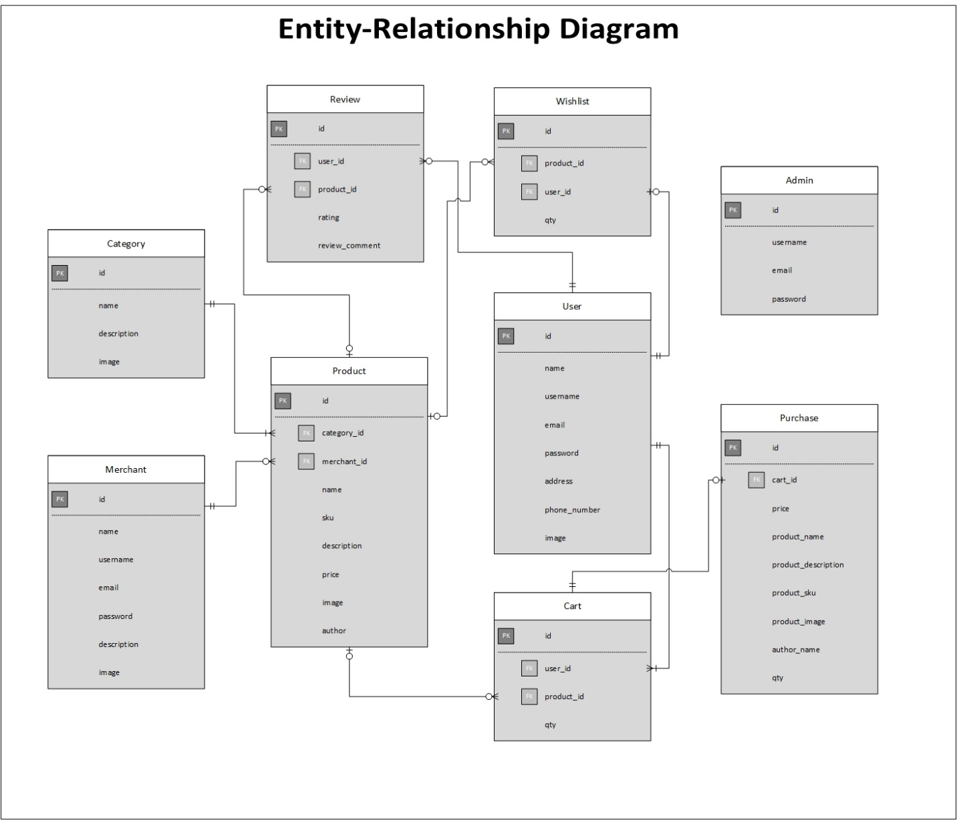

Gambar 4 Entity-Relationship Diagram

# User Stories

## User (Customer)

As a customer, I want to log in to or log out from my account so I can use the apps with my account credentials.

As a customer, I want to manage my account so I can update my account information.

As a customer, I want to show all and nearby tailors so I can find tailor easier.

As a customer, I want to search designs and tailors so I can find by keyword faster.

As a customer, I want to swap my face with face in the design so I can consider if the design fits me.

As a customer, I want to chat a tailor so I can negotiate and customize the design I want.

As a customer, I want to order a design so I can buy clothes same as the design everytime and everywhere.

As a customer, I want to show all my ordered design so I can order the same design easier.

## Tailor

As a tailor, I want to log in to or log out from my account so I can use the apps with my account credentials.

As a tailor, I want to manage my account so I can update my account information for personal branding.

As a tailor, I want to add my designs so I can let customer know what clothes that I can produce and they can order the designs.

As a tailor, I want to manage my designs so I can update or remove it easier.

As a tailor, I want to reply customer’s chat so I can negotiate and understand what customer want.

As a tailor, I want to accept or reject incoming orders so I can choose the orders which I can produce.

Change Log

|  |  |  |
| --- | --- | --- |
| Revision | Description | Date |
| 0.0.1 | Initialization Document | 25 September 2020 |
| 0.0.2 | Update introduction | 27 September 2020 |
| 0.0.3 | Update usability, user characteristics, limitations, and assumptions and dependences | 28 September 2020 |
| 0.0.4 | Update general description (perspective), functional requirement (use case diagram), and user story | 29 September 2020 |